A synchronous programming

Pydantic module

Secure 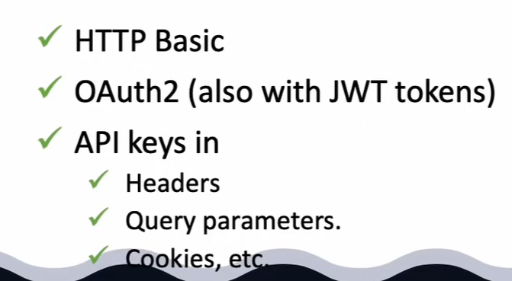

Sql support